# **Setting Up Art Assets**

**NOTE: **Names of files and folder names will show up in the NFT metadata EXACTLY how you write them so spell and capitalize properly\*\***

## Overview/Terminology

* **Metadata Category:** 
  + On the NFT, it's the category for each trait
  + Ex: Background, Pot, Leaves, Stem, Head, Hat are the Metadata Categories

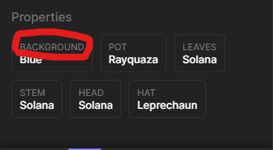

* **Metadata Trait:** 
  + On the NFT, its the trait name within each category
  + Metadata Trait = File name
  + Ex:

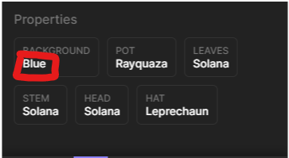

## Folders

* Naming the folders:
  + Folders can be named whatever you want. If you name them what you want the metadata category to be, then that will save you one step later down the line

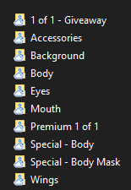

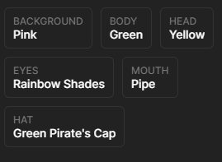

## Files

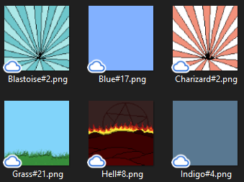

* Must be in this format “<NAME>#<RARITY WEIGHT>.png”
* LOWER NUMBER = MORE RARE
* The weights DO NOT have to add up to a certain number
* The weights are relative to all the other files within the same folder
* Ex. of how the algorithm works:
  + Gray#2.png, Red #3.png, Blue#5.png, Green #10.png
  + So the sum of these numbers is 20. The alg chooses a random number from 1-20
  + We can think of the weights like this, you add to the previous

| **Trait + weight** | Gray +2 | Red +3 | Blue +5 | Green +10 |
| --- | --- | --- | --- | --- |
| **Range** | 1-2 | 3-5 | 6-10 | 11-20 |

* + So a random number is chosen from 1-20, whichever range that number lands in is what trait gets chosen
  + Ex: RandomNum = 3 -> Red chosen
  + Ex. RandomNum = 12 -> Green chosen

## 1/1’s

* Make a Folder named “Limited Edition 1 of 1”(or whatever you want along those lines)
  + Put all 1/1’s as a fully assembled pngs in that folder
  + 1/1 file names should be <NAME>#1.png

# Metadata

#### Instructions: Each heading corresponds to a sheet in the Metadata.xlsx spreadsheet. Fill out all this info. DO NOT add rows or columns to any of the sheets

### NFT Distribution

* **Category**
  + They name of the drop that NFTs belong to
  + Typically this will be: giveaway, whitelist, launch. And more as needed
* **Number of NFTs**
  + The number of NFTs you want for that drop
* Ex: **Category:** Giveaway, **Number of NFTs:** 20
* Once the final candy machines are made and paid for, these numbers **CANNOT** be changed. You would have to pay the upload fees again to change these numbers after.

### General Info

* **Name Prefix**
  + The name of the NFT that comes before the edition number. Typically should not be plural.
  + Ex: VenusSolTrap #69. For this example **Name Prefix** = VenusSolTrap
* **Project Description**
  + Description that shows up on each NFT
  + Ex:

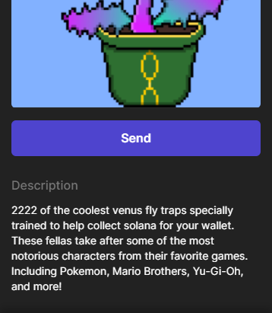

* **Collection Name**
* **Collection Family**
  + Ex of Collection Name/Family: <https://solanart.io/collections/galacticgeckospacegarage>
    - Collection Family = “Galactic Space Gecko Garage”
    - Collection Names = “Galactic Geckos”, “Enigma Crystals”, and “Concordians”
* **Project Symbol**
  + Add up to ten capital letters
* **Sales Fee**
  + Percentage taken from each sale on secondary marketplaces.
  + Sales fee is typically 2.5%-10%
    - Ex: if the sales fee is 10%, and someone sells our NFT for 5 sol on Solanart, then the team receives 0.5 SOL from that sale
* **Website**
  + Leave blank if I'm making the website
* **Dimensions: Height (optional)**
  + **Defaults to 512**
  + The height of the NFT image
* **Dimensions: Width (optional)**
  + **Defaults to 512**
  + The width of the NFT image

### Mint Split

* **Wallet Address**
  + wallet address of each mint split.
* **Mint Percentage**
  + Percent of mint for each given wallet.
  + Percentages for all wallets must add up to 100
  + Just write the whole number
    - Ex: Don’t write 0.25 or 25%. Write 25
* Ex:
  + **Wallet Address:** 5uz4pE4cbsRQjZA1v6BFrK5688avo9xBzKbxYNERfVWR
  + **Mint Percentage**: 35
* These CAN be changed any time before mint
* **4 WALLETS MAXIMUM**, put in my percentage as well please, it's the first one where the wallet is already filled in

### 

### Royalty Split

* **Wallet Address**
  + wallet address of each royalty split. If you want a community wallet that gets royalties put it here as well
* **Royalty Percentage**
  + Percent of Sales fee for each given wallet.
    - Ex: If sales fee = 10%, and your royalty split is 20%. Lets say someone sold our projects NFT for 100 SOL. Since the sales fee = 10%, we as the project creators would get 10 SOL from that sale and since your personal royalty split is 20%, you would get 2 SOL
  + Percentages for all wallets must add up to 100
  + Just write the whole number
    - Ex: Don’t write 0.25 or 25%. Write 25
* Ex:
  + **Wallet Address:** 5uz4pE4cbsRQjZA1v6BFrK5688avo9xBzKbxYNERfVWR,
  + **Royalty Percentage**: 35
* These CAN be changed at any time in the future
* **4 WALLETS MAXIMUM**, put in my percentage as well please, it's the first one where the wallet is already filled in. My percentage should be the same as my mint percentage unless we have discussed otherwise

### Layer Combinations

* Choose the combination of layers you want in the collection
* **Name**
  + A short name to describe this combination of layers, this is just for organization, it will not show up on the NFTs anywhere. What makes this combination unique
* **Weight (optional)**
  + This works the same way as the weight for the files but it’s for choosing between which combination to use
* **Required Number (optional)**
  + Number of NFTs you want with this combination of layers
* **Save Categories (optional)**
  + **Defaults to all categories**
  + In the NFT Distribution category, we specify the number of NFTs we want per category.
  + This option allows you to send the NFTs generated by this layer combination to the chosen categories
  + Format should be the category names separated by commas (<category name> , <category name>, …
    - Ex:
      * I want to have all the 1/1 NFTs only be in the launch and whitelist categories, not for giveaway.
      * I would set “Save Category” to “launch,whitelist”
* **Link? (optional)**
  + **Defaults to true**
  + Choose true or false
  + Choose whether you want this combination of layers to follow the linking rules
    - False = Don’t follow linking rules for that layer combination
* **Avoid? (optional)**
  + **Defaults to true**
  + Choose true or false
  + Choose whether you want this combination of layers to follow the avoidance rules
    - False = Don’t follow avoidance rules for that layer combination
* **Each Layer**
  + Layer 1 = BASE layer
    - (Background will likely be Layer 1 since and then the layers stack on from there)
  + Write the name of the layers you want in this combination.
  + Layer names must be exactly the same as the Metadata category folder names
  + Add more columns as needed
  + **Folder**
    - The folder for the layer
  + **Metadata Category (optional)**
    - **Defaults to Folder**
  + **Skip % (optional)**
    - Percent chance of that layer not being selected in a given NFT
    - Write this as a whole number. Do not 0.25 or 25%. Write 25
    - Do not use this on layers that need to be there all the time, like the background for example
    - Ex: You want 25% of your collection to have no “Hat” layer, set Skip % to 25.

#### 

### Avoid Rules

* Whenever (Folder1,Trait1) are in an NFT, avoid adding (Folder2,Trait2) to that NFT
* **Folder1,Trait1 | Folder2,Trait2**
  + Trait = the Metadata Trait/File Name
    - For the Trait1 and Trait2, you can write “all” to avoid a whole Folder
    - Ex: Hat,Red | Shoes, all
      * This would mean that when a red hat is selected for an NFT, it will not add shoes to that NFT

### Link Rules

* Whenever (Folder1,Trait1) is selected in an NFT, always add (Folder2,Trait2) to that NFT
* If there are multiple links, one will be chosen based off their weights
  + Ex:
    - Hat, Red | Shoes,Converse
    - Hat, Red | Shoes, Vans
    - If both of these links were set, then if a Red Hat was chosen, either Converse or Vans Shoes would be chosen
* **Folder1,Trait1 | Folder2,Trait2**
  + Trait = the Metadata Trait/File Name
    - For the Trait1 and Trait2, you can write “all” to link a whole Folder
    - Ex: Hat,Red | Shoes, all
      * This would mean that when a red hat is selected for an NFT, choose from all the shoes for that NFT